WebCADbyFeatures: A Computer System for the Collaborative Design of Feature-Based Parts Through the Internet

Alberto J. Alvares^{1,*}, João Carlos E. Ferreira²

¹ Universidade de Brasília, Departamento de Engenharia Mecânica e Mecatrônica, Grupo de Inovação em Automação Industrial (GIAI - GRACO), CEP 70910-900, Brasília, DF, Brazil,alvares@AlvaresTech.com
² Universidade Federal de Santa Catarina, Departamento de Engenharia Mecânica, GRIMA-GRUCON, Caixa Postal 476, CEP 88040-900, Florianópolis.

In this work a system will be presented, which was developed for the collaborative design of feature-based cylindrical parts through the Internet, integrated with a CAD/CAPP/CAM system, using an approach based on multi-agent systems. The information referring to the features is manipulated through a relational database management system. The Graphic User Interface (GUI) is implemented in Java and HTML. In this GUI, the user inputs the information on the design features that compose the part. Then these data are sent to the server. Since the part is cylindrical, the user models the part in two dimensions, and it can be visualized in 3D, through VRML.
A database that stores the information on the product modeled by features, containing information associated with the form features, material features, tolerance features and technological features (superficial treatment, thermal treatment and production data) was implemented. Theses combined information allows the mapping of design features to machining features, which is fundamental for the process planning of the part. The database information is described in this article using the IDEF1X information model.
©2010 Journal of Mechanical Engineering. All rights reserved.
Keywords: Features, CAD/CAPP/CAM, Collaborative Design, E-Manufacturing, MAS

1. Introduction

A new revolution in the labor system adopted in the manufacturing companies is occurring, which corresponds to the change from computer-aided activities (i.e. CAD, CAPP, CAM, CAP, etc), developed in the 80's and 90's of the 20th century, to the e-Work activities (electronic-Work), which characterize the principle of work in the information era, with intensive use of Information Technology (IT).
IT, especially the network communication technology and the convergence of wireless and Internet network-based technologies, is opening a new domain for building the future manufacture environments called e-Mfg (electronic-Manufacturing), using labor methods based on collaborative e-Work, especially the activities developed during product development in integrated and collaborative CAD/CAPP/CAM environments. This is a new paradigm for these computer systems based in global environments, network-centered and spatially distributed, enabling the development of activities using e-Work. This will allow the product designers to have easier communication, making it possible the sharing and collaborative design during product development, as well as the teleoperation and monitoring of the manufacturing equipment.
This work presents a description of the implementation of the WebMachining system and methodology (http://WebMachining.AlvaresTech. com), developed in an e-Mfg context aiming at CAD/CAPP/CAM integration for the remote manufacture of cylindrical parts through the Internet. The methodology and its implementation are conceived with the collaborative modeling paradigm based on the synthesis of design features, in order to allow the integration of the activities of collaborative design (WebCADbyFeatures), generative process planning (WebCAPP) and manufacturing (WebTurning). The system is implemented in a distributed agent environment (agents' community), and the architecture is structured in three levels: Design, Process Planning and Manufacturing; and the Knowledge Query and Manipulation Language (KQML) was adopted as the pattern language of messages among the design, process planning and manufacturing agents.
In this paper the WebCADbyFeatures system is described, which is an interface agent with the user that allows the collaborative modeling of a cylindrical part through the Internet in the context of the WebMachining system.
In recent year, with the improvement of FEM (finite element method) and the development of computer technology, numerical simulation technology based on FEM is increasingly becoming a powerful tool to analyze the hot rolling and the hot forging process of steel and so on [1] to [5].
The processing tube tension-reducing is an important and complex deformation process in the producing seamless tubes, which is influenced by the materials properties, deformation temperature and rolling rate, stress, contact and friction condition, reducing size and others, which are a non-isothermal steady-state coupled with non-steady-state three-dimensional thermo-mechanical process. (Style: Normal text)

2. Collaborative CAD and Related Systems

In design engineering practice, even more activities associated with the several manufacturing aspects are being considered during the design phase. Feature-based modeling has been used in the integration of engineering activities, from design to manufacturing. Thus, the concept of features has been used in a wide range of applications such as part design and assembly, design for manufacturing, process planning and other countless applications. These applications are migrating to heterogeneous and distributed computer environments to give support to the design and manufacturing processes, which will be distributed both in space and in time.
It should be noted that it is undesirable and frequently unlikely to require that all participants in the product development activities use the same hardware and software systems. Consequently, the components should be modular and communicate with the others through a communication network, for effective collaboration.
Many research efforts have been made in the development of design environments oriented to computers networks, usually called network-centered. Shah et al. (1997) developed architecture for standardization of communication between the kernel of a geometric modeling system and the applications. Han and Requicha (1998) proposed a similar approach that enables the transparent access to several solid modelers.
Smith and Wright (2001) describe a distributed manufacturing service called Cybercut (http://cybercut.berkeley.edu), which makes it possible the conception of a prismatic part that will be machined using a CAD/CAM system developed in Java in a context of remote manufacture.
Shao et al. (2004) describe a process-oriented intelligent collaborative product design system based on the Analysis-Synthesis-Evaluation (ASE) design paradigm and the parameterization of product design, using agents.
Hardwick et al. (1996) propose an infrastructure that allows the collaboration among companies in the design and manufacture of new products. This architecture integrates WWW for sharing information in the Internet using the STEP standard for product modeling. Martino et al. (1998) propose an approach to integrate the design activities with the other manufacturing activities based on features, which supports both feature-based design and feature-recognition.
Collaborative modeling systems typically have a client/server architecture, differing in the functionality and data distribution between customers and servers. A common problem in the client/server systems is associated with the conflict between the limitation of the complexity of the client application and the minimization of the network load. A commitment solution can be conceived between the two ends, the so-called thin and fat clients. A pure thin client typically architecture places all the functionality in the server, which sends an image of its user interface to be shown on the client.
On the other hand, a pure fat client offers total interaction and local modeling, maintaining its own local model. Communication with the server is required when it is necessary to synchronize the data modifications in the local model with the other clients.
Lee et al. (1999) present the architecture of a network-centered modeling system based on features, in a distributed design environment, called NetFeature System. This approach combines feature-based modeling techniques with communication and distributed computing technologies in order to support product modeling and cooperative design activities in a computer network.
The WebSpiff system (Bidarra et al., 2001) is based on a client/server architecture consisting of two main components on the server side: (i) Modeling System SPIFF that supplies all the functionality for feature-based modeling, using the modeling kernel ACIS (Corney and Lim, 2001); (ii) Session Manager that supplies functionality to start, to associate, to finish and to log out a modeling session, as well as manages all the communications between the SPIFF system and the clients.
Li et al. (2004) and Fuh and Li (2004) mention several distributed and integrated collaborative design systems and Concurrent Engineering, and none of such systems implements collaborative design activities integrated with process planning and remote manufacturing systems via Web for the cylindrical parts domain, with symmetrical and asymmetrical features. Most of those systems consider prismatic parts, like WebCAD 2000 of the Cybercut system, which does not implement collaborative design (Smith and Wright, 2001).
The development of the WebCADbyFeatures collaborative design system differs from the above systems, because it models cylindrical parts, based on synthesis of design features (symmetrical and asymmetrical), having as motivation the development of an integrated CAD/CAPP/CAM system that allows the collaborative design through the web, in a context of Concurrent Engineering.

3. Methodology of the WebMachining System

The integration among the production stages is one of the roads that should be explored in the search to reduce manufacturing costs and times. According to Shah and Mantyla (1995), the product modeling is the central point for achieving such integration. In an integrated production system, the product model, defined in the CAD module, should be available for other modules (CAE, CAPP, CAM, CAQ, etc) so that these can accomplish their functions. These modules should also be capable of sending feedback information to the CAD module, in order to enable the necessary changes in the part to be made during the design stage (for instance, due to problems detected in production). The use of features as an information base for product modeling is the road to reach this integration (Tönshoff et al., 1994; Salomons et al. 1993).
IT, especially communication network and Internet technology, is beginning a new domain for building the future CAD/CAPP/CAM environments (Lee et al., 1999), and they are potential candidates to make it possible the development of integrated systems. This will allow the designers to have easier communication, enabling the sharing and the collaborative design during the product development. With the growth of the popularity of the navigators based on WWW, it is becoming more evident that the network-centered design environment will become a new paradigm for product development.
Figure 1 presents part of the IDEF0 model of the proposed system, called WebMachining (Alvares and Ferreira, 2005; 2006; 2008) and (Alvares et al., 2008), where a methodology is presented for integrating CAD/CAPP/CAM for the remote manufacture of rotational parts through the Internet. The proposed methodology is divided into three basic activities: collaborative product modeling (WebCADbyFeatures), Generative CAPP (WebCAPP) and CAM (WebTurning).
The product development procedure in the WebMachining architecture (http://WebMachining.AlvaresTech.com) begins in the collaborative modeling of a part using features, where two or more design agents cooperate during modeling the part in 2D and 3D, in a context of remote manufacturing, using the Web as a means of communication, in client-server computer model.
The client, WebCADbyFeatures interface agent (fig. 2) is connected to the neutral feature modeler via Web, and it begins the instantiation of a new part to be modeled from a database, using a library of standardized form features, made available by the system.
The Graphic User Interface (GUI) is implemented in Java and HTML. In this GUI, made available by browser, the user inputs the information on the design features, which will compose the part in a collaborative design context. Then, these data are sent to the server. Since the part is cylindrical, the user models the part in two dimensions, and may visualize it in 3D, through VRML. A database was implemented in MySQL that stores the information on the product modeled by features, containing information associated with the form features, material features, tolerance features and technological features (surface treatment, thermal treatment and production data). This combined information allows the mapping of the design features into machining features, which is fundamental for process planning.
After concluding and validating the model, the created part is stored and made available to the CAPP module to generate the process plan with alternatives for the part, its linearization and the representation of the linearized process plan based on STEP-NC (ISO 14649 - Part 12), as well as the generation of the NC program for a CNC lathe (http://video.graco.unb.br).
The communication with the CNC turning center Romi Galaxy/CNC Fanuc 18i-Ta is accomplished through an Ethernet connection (physical and connection layers of the ISO/OSI standard), using the TCP/IP protocol (network and transport layers of the ISO/OSI standard) associated with the application protocol Focas1/Ethernet libraries of Fanuc. Focas1 (Fanuc Open CNC API Specifications) is an API for developing applications using a standardized data structure, which has access to 300 CNC functions (http://webdnc.graco.unb.br).
After finishing the CAPP module (WebCAPP), the work order is sent to the remote manufacture system, which performs scheduling, making it available the necessary resources for the manufacture of the part (NC program, tools, setup and blank).
The second module, WebCAPP, incorporates characteristics of a generative CAPP system, which interprets the design definitions and determines how the part is machined using the manufacturing module. WebCAPP maps the design features into manufacture features, determines the machining operations that can produce the features, and defines a sequence of machining operations with alternatives (figure 3).

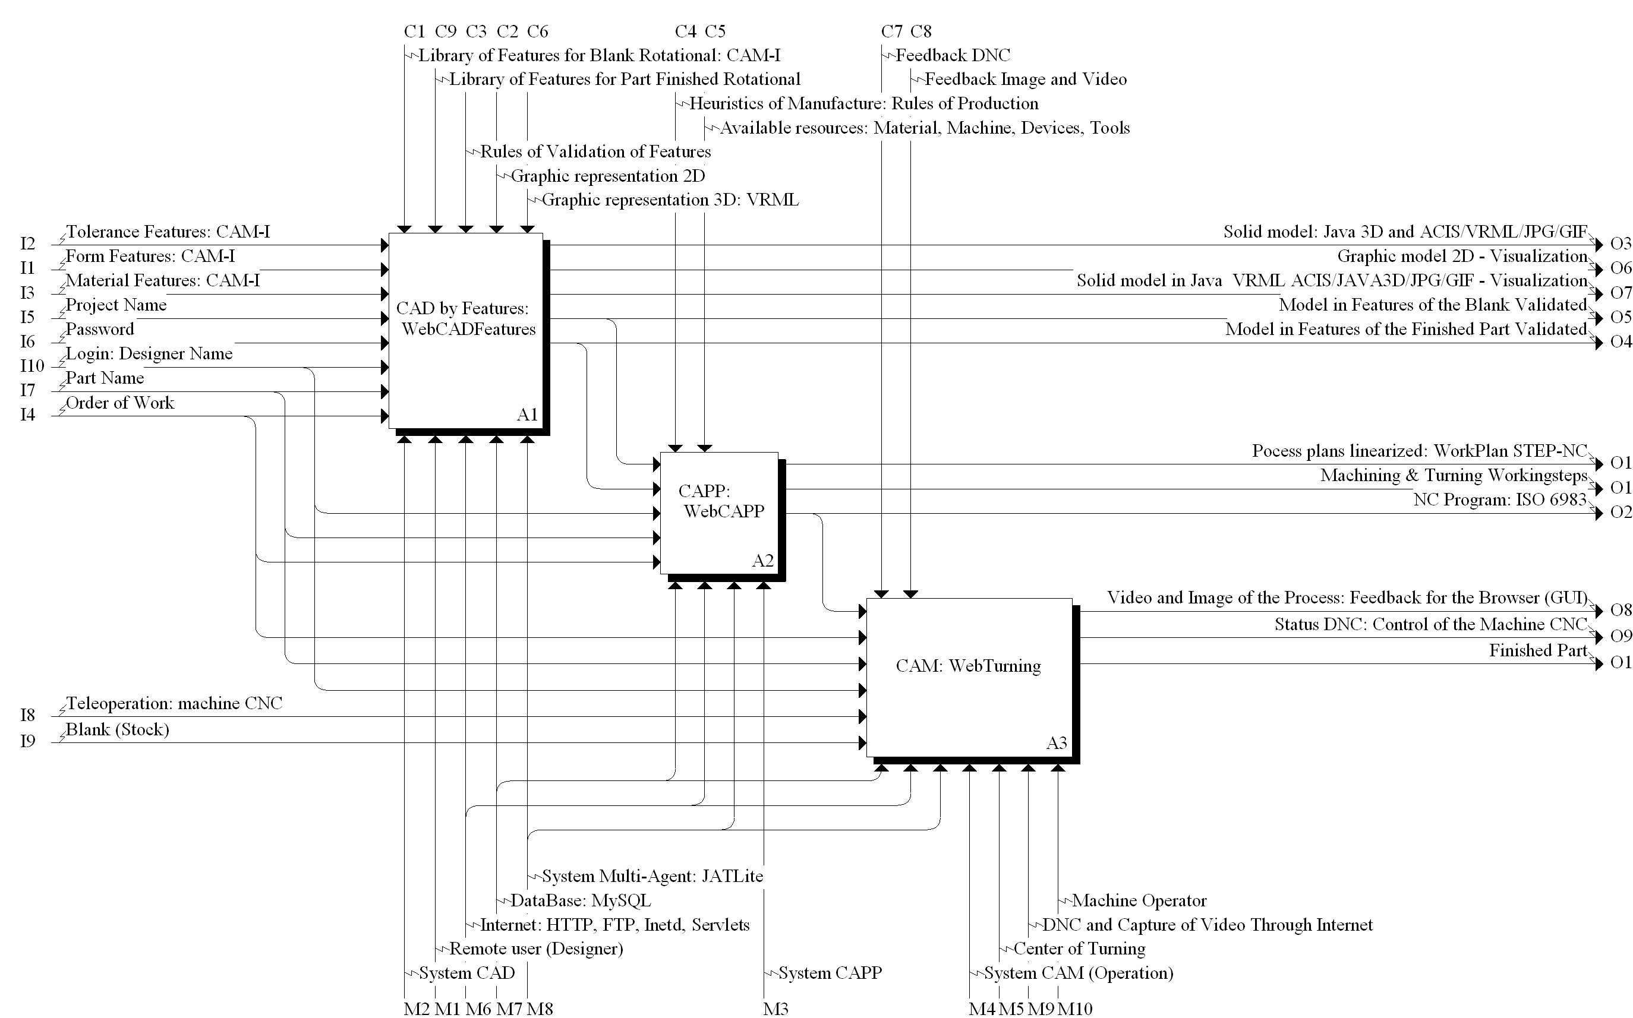

Figure 1 Modeling of the WebMachining system, using the IDEF0 methodology

That sequence of machining operations is presented in an AND/OR graph composed of workingsteps, which are sets of machining pieces of information proposed in the ISO 14649 - STEP-NC standard (ISO 14649-1, 2002; Han, 2001) (figure 4). The method for mapping the design features into machining features, as well as the procedure for generating the AND/OR graph, were described in Álvares et al. (2008). The NC program for manufacturing the part is also generated in the WebCAPP module, and an example of a generated NC program is given in figure 5.
The teleoperation system of the CNC turning center, called WebTurning (figures 1 and 6), is based on a client/server architecture. The server is composed of two modules: WebCam and WebDNC servers, represented by the programs located at a workstation (Linux platform), logically connected via TCP-IP sockets and Ethernet network to the machine-tool and to the clients, being responsible for image capture (http://video.graco.unb.br) and supervisory control of the CNC turning center, respectively; the clients' side is represented by Java Applets and HTML pages.
WebTurning's teleoperation server is composed of the video server and teleoperation servers of the CNC machine, which makes it available command services, program execution, program download and upload, treatment of mistakes and other functions associated with the DNC1 communication protocol (CNC Fanuc 18i-TA), accomplishing the remote supervision of the machine. Every control action is executed locally, based on the delay of the TCP/IP protocol. The video server performs video and image capture (through four cameras) and for their distribution through the TCP/IP protocol (Internet). The other servers, associated with the teleoperation services, work in a bi-directional way, receiving commands through the Internet and sending machine status data.

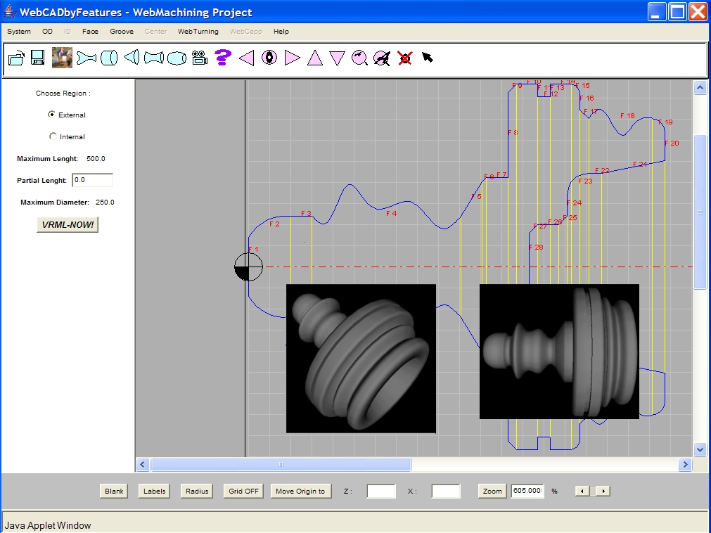

Fig. 2. Main window of the WebCADbyFeatures system, showing the profile of a rotational part

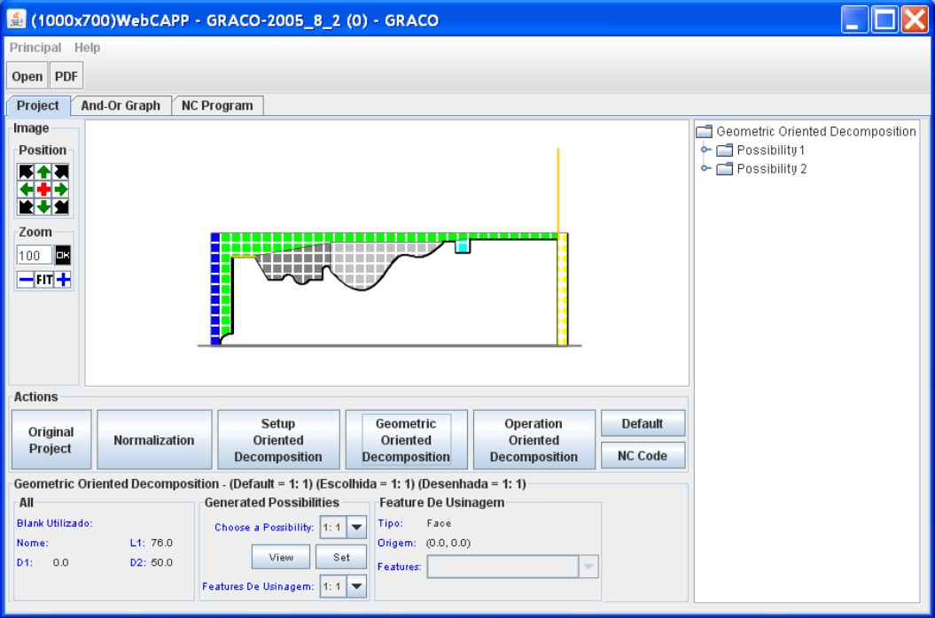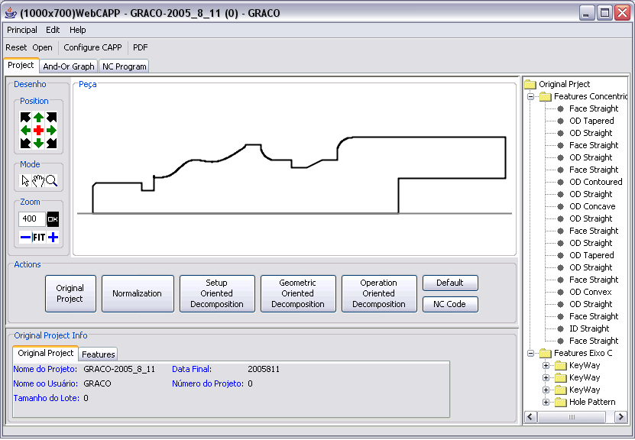

Fig. 3. Feature-mapping in the WebCAPP module

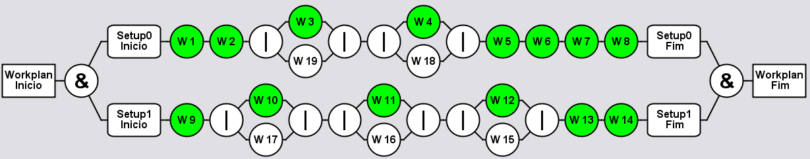

Fig. 4. AND/OR graph, which is composed of Workingsteps

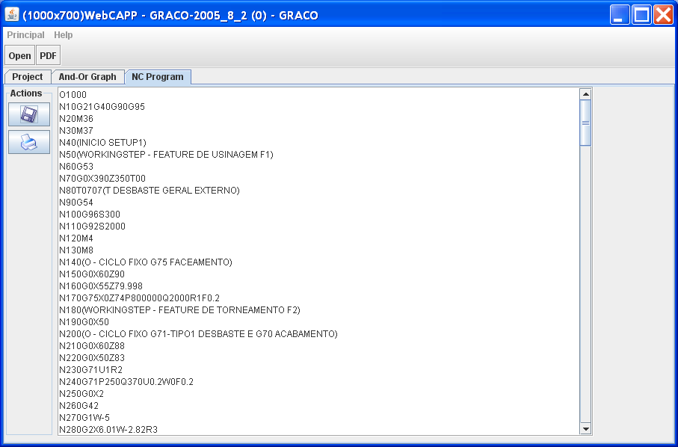

Fig. 5. Generation of the NC program in the WebCAPP module

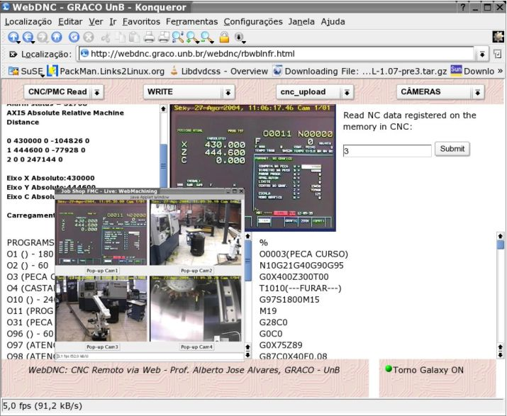
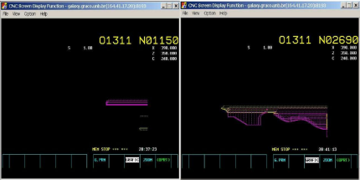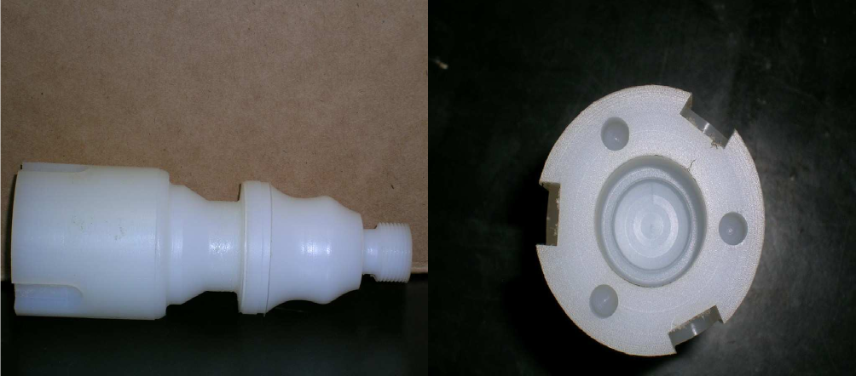

Fig. 6. Interface of the WebTurning module, responsible for the teleoperation and the remote monitoring of the CNC turning center Galaxy M15: CNC simulation and machined part

fffffffffffffffffffffffffffffffffffffffffffffffffffffffffffffffffffffffffffffffffffffffffffffffffffffffffffffffffffff

X REFERENCES

- Wagner, A., Bajsić, I., Fajdiga, M. Measurement of the surface-temperature field in a fog lamp using resistance-based temperature detectors. Strojniški vestnik – Journal of Mechanical Engineering, February 2004, vol. 50, no. 2, p. 72-79.
- Boguslawski L. Influence of pressure fluctuations distribution on local heat transfer on flat surface impinged by turbulent free jet. Proceedings of International Thermal Science Seminar II, Bled, June 13.-16., 2004.
- Muhs, D. et al. Roloff/Matek mechanical parts, 16th ed. Wiesbaden: Vieweg Verlag, 2003. 791 p. (In German). ISBN 3-528-07028-5.
- ISO/DIS 16000-6.2 (2002) Indoor Air - Part 6: Determination of Volatile Organic Compounds in Indoor and Chamber Air by Active Sampling on TENAX TA Sorbent, Thermal Desorption and Gas Chromatography using MSD/FID. Geneva, International Organization for Standardization.
- Goon, B. (2005) Effects of excessive drinking on sport participation. Retrieved on 7. 8. 2006, from http://www.excessive_drinking.com.

