METHODOLOGY FOR INTEGRATING CAD/CAPP/CAM AIMING FOR MANUFACTURING OF PRISMATIC PARTS ADHERENT TO THE STEP-NC

Jhon J. Goyes Collazos, jhonjgc80@hotmail.com
Alberto José Álvares, alvares@alvarestech.com

University of Brasilia – Department of Mechanical and Mechatronics Engineering – GIAI (Group of Innovation in Industrial Automation, Brasilia DF – Brazil 70910-900

Abstract. This paper describes a methodology for the integration of a CAD/CAPP/CAM oriented system prismatic machining parts adherent to the STEP-NC standard (ISO 14649). The methodology starts with the product project based on the model of the prismatic part approach using DSG (Destructive Solid Geometry) in which the features of machining are associated to machining operations, thus defining the volume of material to be removed from the workpiece. The modeling of the product (project view) can incorporate decision taken by the designer associated with the activities of the planning process; such has selecting the type and diameter / length of a tool for removing material in a cavity. The output data from the CAD module based on machining features are obtained conforming to the application protocol AP203 and AP224, which will be available for use by the CAPP module (Computer Aided Process Planning). The CAPP module uses the STEP application protocol AP224 and STEP-NC as a basis to define the machining features of the part to be machined on a machining center or a milling machine. One of the outputs generated by the planning process is the numerical control program in the format STEP-NC ARM ISO 14649 with information of machining features, cutting parameters, cutting tools required, fixturing, workingsteps, workplans, among others. The data structure of STEP-NC ARM ISO 14649 is used as input module CAPP/CAM (Computer Aided Manufacturing) that will generate the tool path for each workingstep described in a NC program in the G and M codes (RS274) format to be used in traditional CNC machines without support for STEP-NC. The data generated at each interface of the modules described in the methodology are stored in a database in XML format (ISO 10303 Part 28). With proposed methodology the manufacturing cycle of the product can be performance in less time, with a low cost of manufacture and with a better quality final product.

Keywords: STEP-NC ARM (ISO 14649), CAD/CAPP/ CAM, AP 203, AP224

1. INTRODUCTION

The STEP-NC standard provides a data model as support for the new drivers CNC (Computerized Numerical Control). STEP-NC is currently being developed using two different standards (ISO 14649 and ISO 10303 AP238) in two subcommittees of the technical committee ISO 184. The main difference between the two standards is the extent to which they use the STEP representation methods and technical architecture. STEP provides a modeling language of the information called EXPRESS which is used to specify information models in STEP. Based on this standard, this article describes a methodology for the integration of a CAD/CAPP/CAM system aimed at machining of prismatic parts. In this methodology, the modules of the system are specified in IDEF0 diagrams.
The contents of the paper is structured as follows: The section two provides an overview of the STEP-NC ARM (Application Reference Model) ISO 14649 standard; the section three contain a description of the architecture of CAD system module; the section four presents the architecture for the process planning CAPP module and finally the section five present the architecture for the CAM module.

2. STANDARD STEP-NC

STEP (Standard for the Exchange of Product Model Data) is an international standard (ISO 10303) for representation and exchange of product data. The objective of STEP is to provide a mechanism capable of describing product data throughout the life cycle of a product independent from any system. The nature of this description makes it suitable not only for neutral file exchange, but also as a basis for the implementing and sharing product databases and archiving (Jkemmerer, 1999).
STEP is based on the use of a formal specification language called EXPRESS to specify the product information that will be represented (ISO 10303-11, 1997). The standard consists of the following items among others: Description methods (Part 1 - 19), integrated generic resource (Parts 40-56), application protocols (200-299), implementation methods (Part 20 - 29), application modules (Part 1000 - ). The application protocols define a product data model of a specific application derived from integrated resources with constrains and additional specializations.
The methodology involves the use of application protocols ISO 10303-203 (Configuration Controlled 3D Desings of Mechanical Parts and Assemblies). This provides a structure for exchange of part and identifying of configuration, having or not the information associated with 3D model of the part; ISO 10303-224 (Mechanical Production definition for Process Plan Using Machining Features), This application protocol provides a set of features that can be used as information for the manufacture of parts.
The traditional machine CNC make use of G and M codes (ISO 6983 Numerical Control of Machines – Program Format and Definition of Address Words). The G-code is based only on the path and position of the tool, but provides more information on product and process as topological and geometric information, material of the part, tolerances. Moreover it has the disadvantage that the CNC program is not interchangeable for different drivers and only supports information flow in one direction CAD/CAM to CNC, making it difficult a good performance in machining. To solve these inconveniences the new standard STEP-NC this being developed and at the moment it includes two parts:

2.1. STEP-NC ARM 14649 (Aplication Reference Model)

(ISO 14649, 2003) Industrial automation systems and integration – Physical device control- Data model for computerized numerical controllers. The ISO committee TC 184/SC1 is developing the ISO 14649 standard, this standard uses only the EXPRESS language and methods of implementation of the STEP family, is currently divided as follows:
- Part 1: Overview and fundamental principles
- Part 10: General process data
- Part 11: Process data for milling
- Part 12: Process data for turning
- Part 111: Tools for milling machines
- Part 121: Tools for turning machines

2.2. STEP-NC AIM (Application Information Model) ISO 10303 AP238

(ISO 10303 – 238, 2006) Application interpreted model for computerized numeric controlled. The ISO committee TC 184/SC4 is developing ISO 10303-238 which is a application protocol of the STEP family, used the EXPRESS models in ISO 14649 and with a few modifications to get an application interpreted model – AIM; this model provides a complete description of the part geometry and tolerances, machining information, workingsteps, machining operations, cutting tools.
STEP provides a new data model and interface to CNC incorporating object-oriented techniques based on features. Information such as features to be machined, product process planning, performance of operations and cutting tools will be used. The proposed methodology takes like base the standard ISO 14649 Part 1, Part 10 and the parts corresponding to milling Part 11 y Part 111.
With STEP being extended to model manufacturing information, a new paradigm of integrated CAD/CAPP/CAM/CNC is emerging. The key to this paradigm is that no data conversion is required and the data throughout the design and manufacturing chain are preserved (Xun Xu, 2009). This paradigm is illustrated in the Figure 1.

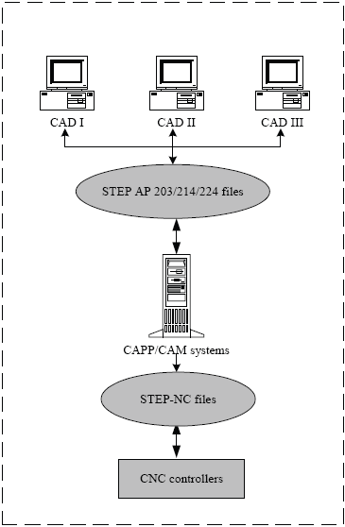
Figure 1. Integrating CAD/CAPP/CAM/CNC
3. MODULAR INTEGRATION ARCHITECTURE CAD /CAPP / CAM

According to (Xu and Mao, 2004) in the effort to achieve integration CAD/CAPP/CAM/CNC, there are two types of traditional models in use, the centralized model (Model A) and the collaborative model (Model B). In the centralized model of proprietary data formats are commonly used, in the collaborative model is added a medium level with a data interchange format neutral. However, some exchange problems still remain, IGES was designed for the exchange of geometric information only, further that there is not an international standard; on the other hand these models have some problems such as loss of data in the transaction from design to manufacturing.
The proposed methodology for integrating the system focuses on the use of the STEP standard to support data exchange and information flow between CAD, CAPP, CAM and CNC. The figure shows the data flow for the two traditional models (Xu, 2006).

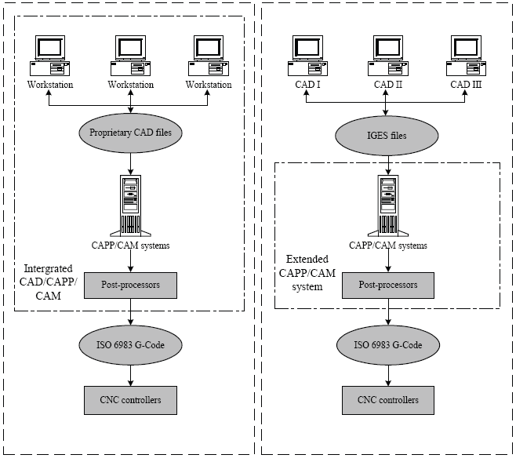
Model A
Model B

Figure 2. Models of integrating CAD/CAPP/CAM/CNC

According to (Xu, 2009) CAD systems are designed to accurately describe the geometry of a piece, on the other hand, systems CAPP / CAM used computer system to generate the process planning and operations of manufacturing control according to geometric information present in the CAD model and existing resources. Finally the output of the CAM system is a set of CNC programs can be run on a CNC machine.
In integrating CAD / CAPP is used the AP224 application protocol as a basis for interconnection between the two modules; generating, in this way, the planning process product data.
This standard AP224 includes geometrical and topological information, of machining features, tolerances, material and process properties and administrative information type.
The proposed methodology specific the modules that make up the system and how these modules interact. The figure 2 shows all inputs, controls, mechanisms and outputs of the proposed system that corresponding to the visualization of the geometric model of the part, the physical file of the process planning under the standard ISO 14649 and finally the respective tool path for the final machined of the piece in code G.

The general architecture for integrating CAD / CAPP / CAM system for prismatic parts proposal is presented in the following graph through modeling IDEF0 diagrams:

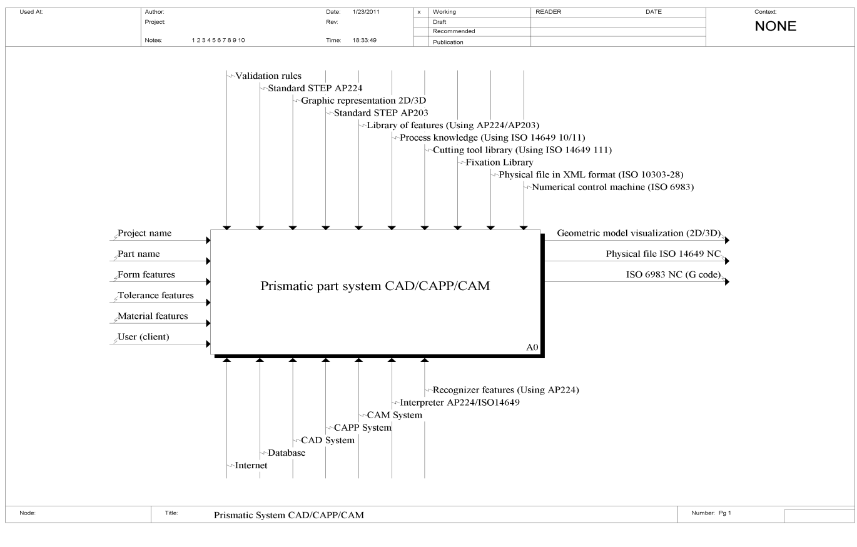
Figure 2. Prismatic system CAD/CAPP/CAM

The following figure shows a more detailed form, the three modules related to the main system functions: CAD, CAPP and CAM that are part of the architecture of the integrated system for prismatic machining.
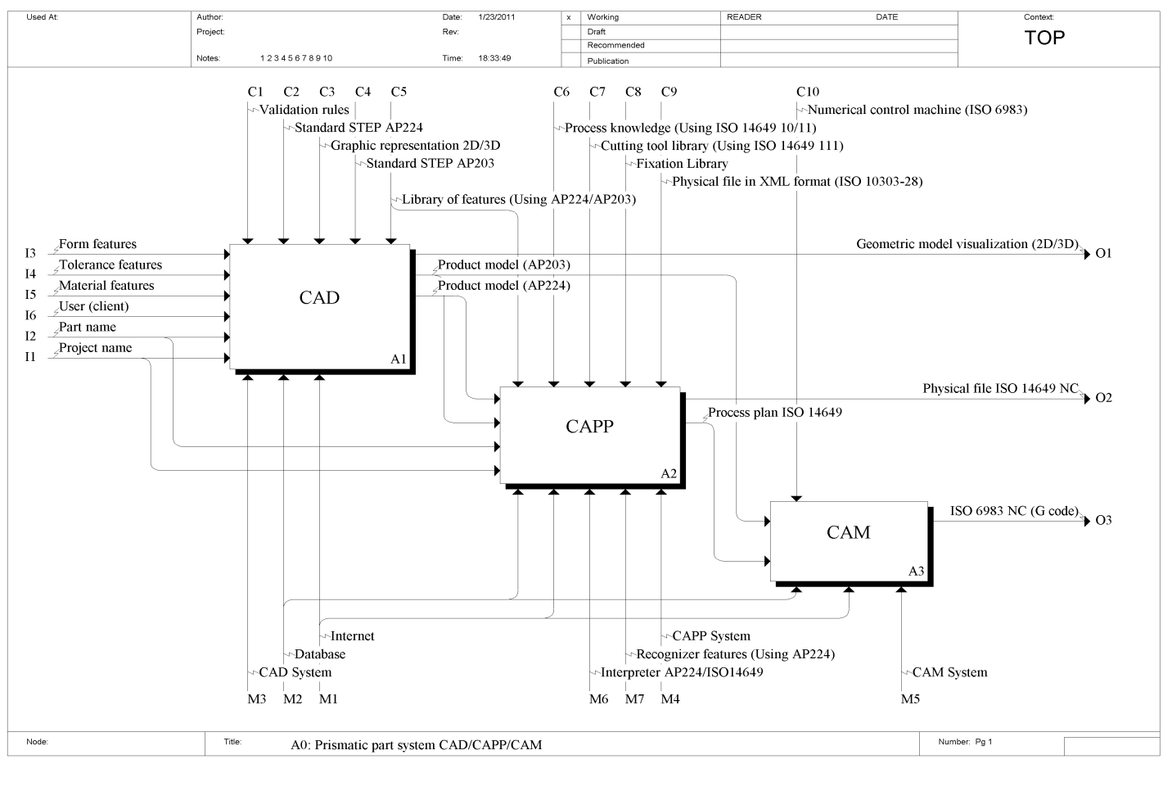
Figure 3. IDEF0: The three main modules of the system.
3.1. CAD Module

In the methodology developed in this paper, is used as a reference the definition of features associated with the application protocol AP224. The proposed architecture of the CAD module is based on the specification and design of the piece using the application protocol AP203, however, because of the AP203 does not include manufacturing characteristics, is necessary to process the geometric data provided by this protocol to identify such geometric features and subsequently associate with data related to the planning and execution of its corresponding machining. Finally, the results obtained are design data based on the application protocol AP224, with geometric information (AP203) and details of the manufacturing characteristics (features). That is, the model of the part that is defined on the geometry STEP is redefined in terms of manufacturing features based on STEP AP224.
In the figure 4 can be viewed in detail the five modules for the functions that are part of the CAD module. The first module for the modeling of the piece to be machined using the library of features based on application protocols AP203 and AP224, This module has as inputs administrative data such as: project name and the part name, besides dates of features of shape, tolerances and material; the part model based on features generated is then validated; the part model validated serves as a gateway to the following two modules, that will generate the STEP AP224 and STEP AP203 of the model of the part respectively, finally in the last module is generated graphic model of the part for it to be displayed.
Thus, the CAD module generates three outputs: product model AP224, product model AP203 and visualization of the geometric model, the first two outputs are used as input for the next module for the CAPP system to be described with more detail in the next section of this paper.

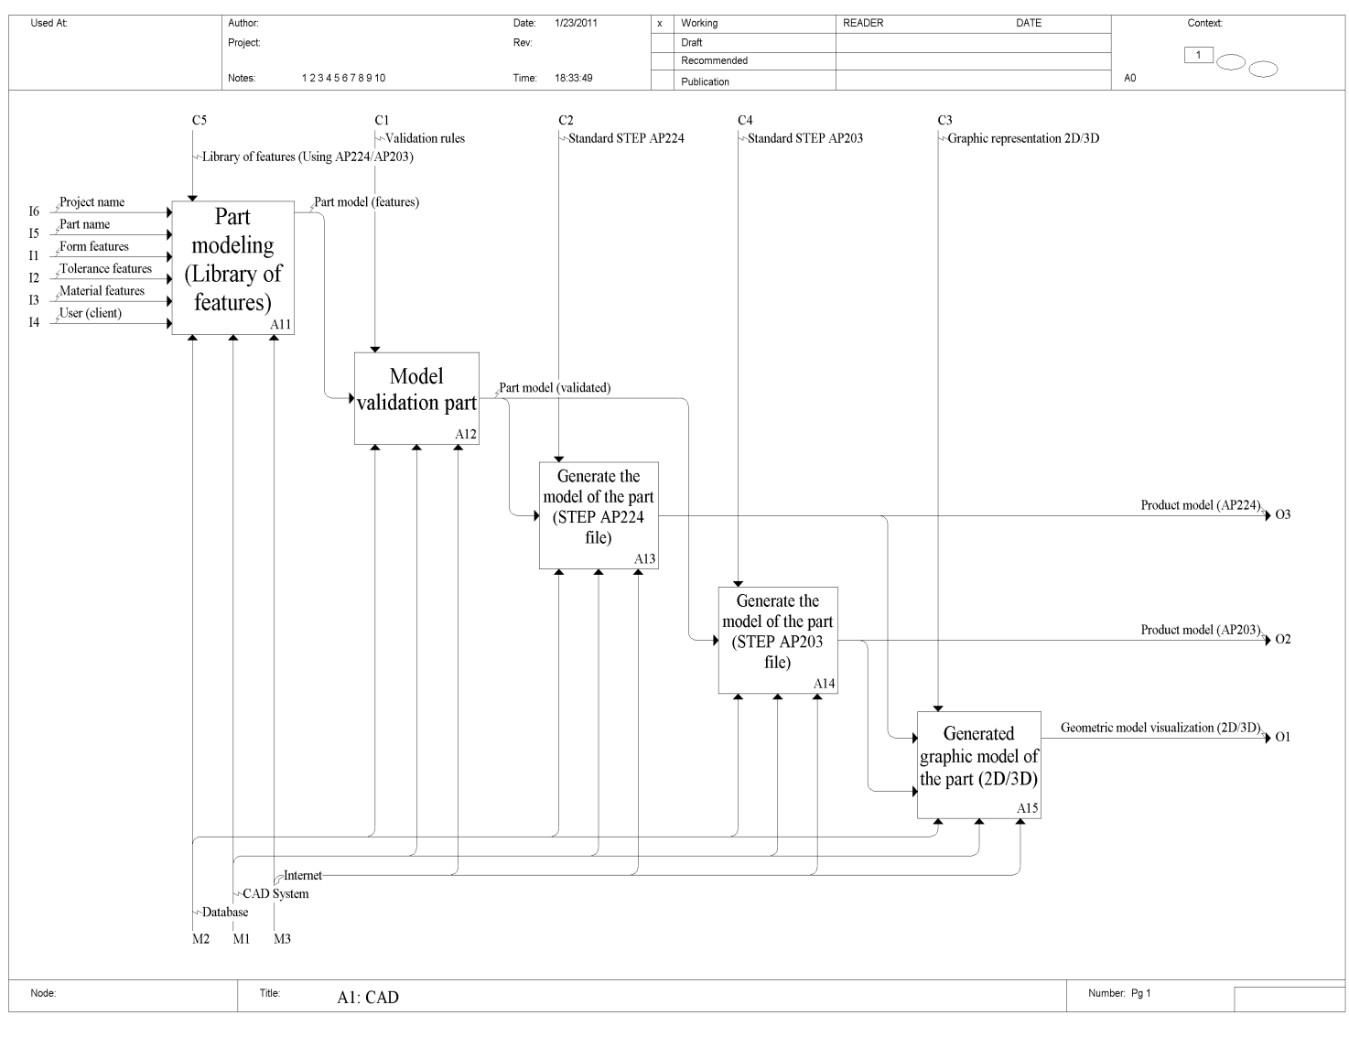
Figure 4. IDEF 0: Modules corresponding to activities of the CAD module of the system.
3.2 CAPP Module

According to (Amaitik, 2005) a CAPP system can be defined as the functions that using computers to assist work planners processes. The main goal of CAPP is to generate the computer processes planning that can replace planner’s processes when knowledge of planning processes and work experience are incorporated into computer programs. The architecture of process planning phase, is based on the interaction of CAPP activity of the system and a database with information of the machine tool, cutting tool types, types of material for the blank.
According to (Xun W. Xu, 2006) when the CAPP module is connected to the database, it will be possible to optimize the sequence of machines, machine tool selection and cutting tools in the planning stage to generate the corresponding file in the format STEP-NC, in this case, file ARM ISO 14649, that can be directly used by a CNC machine.
This ISO 14649 physical file will be generated in XML format (ISO 10303-28) and contain information about part design, manufacturing features, fixing requirements, sequences of the manufacturing process, set-ups and cutting tools. The information in this file can also be used as input to CNC controllers STEP-NC enabled.
In the proposed methodology an XML file format of data in STEP AP224 is mapped to produce the corresponding machining operations in order to generate the planning process, also in XML format according to the STEP-NC standard (14649).
The following figure presents a model in IDEF0 diagrams with the two modules that are part of the activity corresponding to CAPP. In the first module takes as inputs the two outputs coming from the activity CAD corresponding to product model AP224 and AP203, based on this information and use of library features (AP224/AP203), and a process of knowledge use (ISO 14649 10-11), it performs a process of extraction of features to create an archive of features under the ISO 14649 standard that will be taken later to the next module that will use a library of cutting tools for milling based on ISO 14649-111 and also an fixing library, to generate the process planning information and physical file XML format according to ISO 14649.

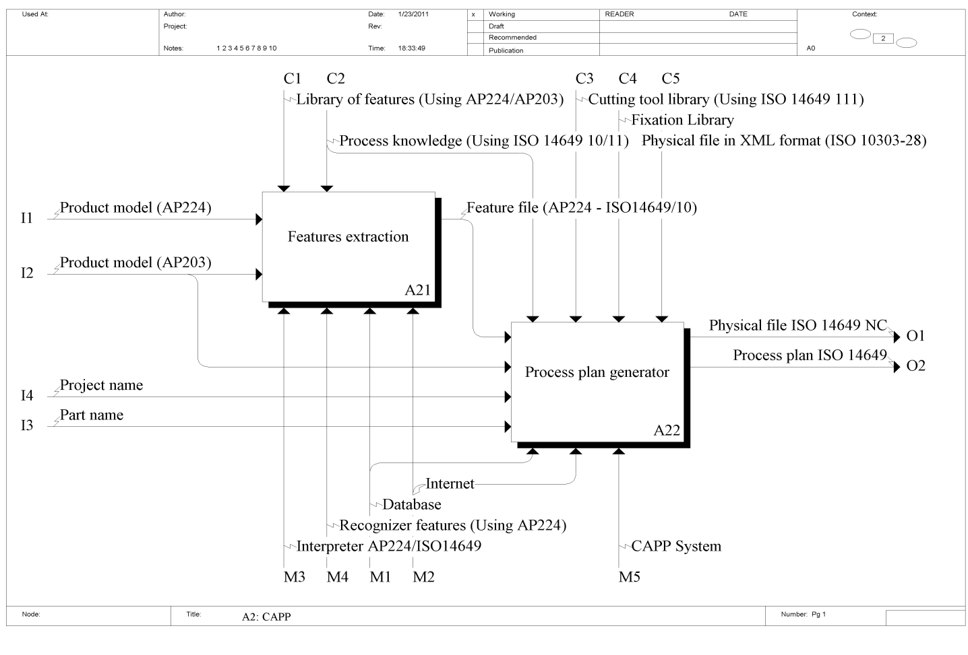
Figure 5. The main modules corresponding to activities of the CAPP module of the system.

The Figure 6 shows in more detail the modules that are part of A21 activity (Features Extraction), in the first module identifies the features of the product model in AP203 and generates a valid set of features that will serve as input for the following module which shall, also, another entry corresponding to product model in AP224, in this last module is generated file of features with STEP data structure.

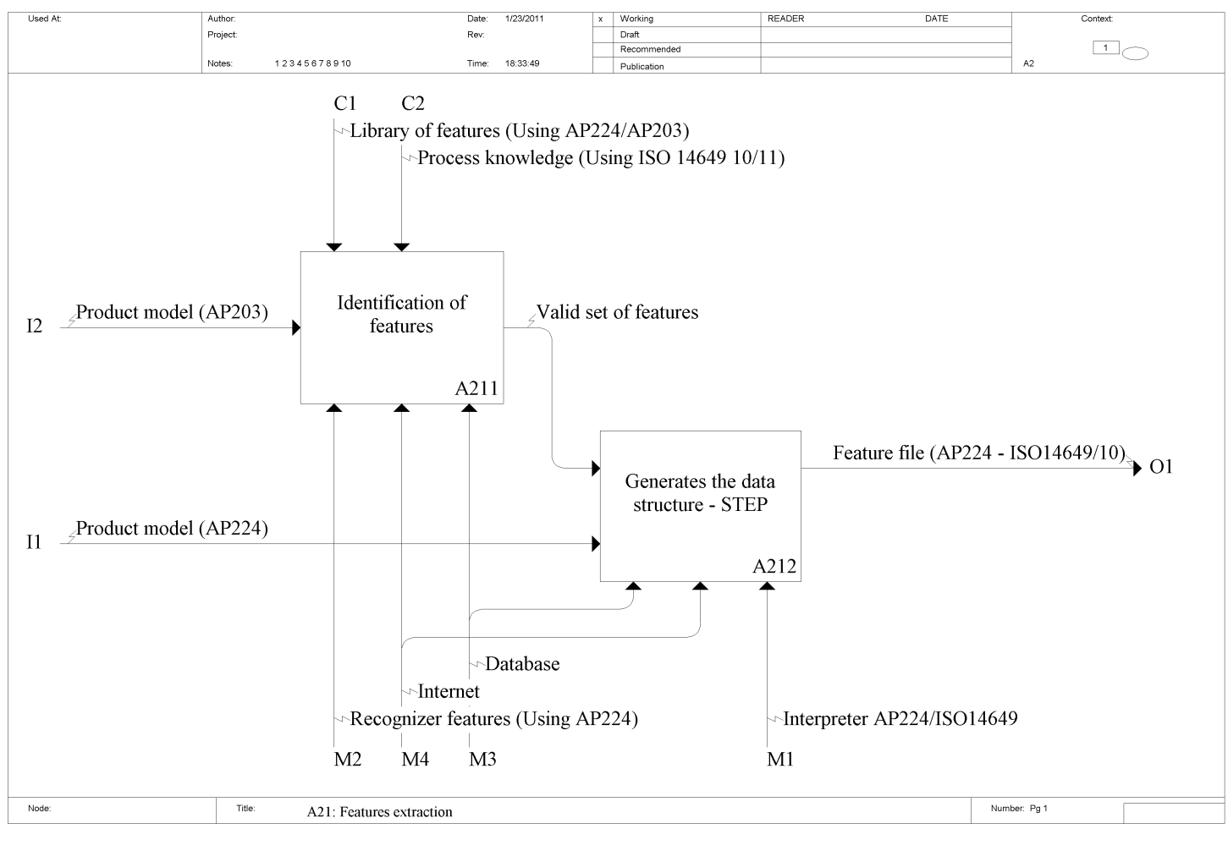
Figure 6. The corresponding modules to activity A21 (Features Extraction) of the CAPP module of system.

The next IDEF0 model shows the modules corresponding to activities that are part of A22 activity (Process Plan Generator) in the Figure 5. To generate the corresponding process plan, there are 5 activities defined as follows:
The first specifies the fixtures and set-ups through a library of fixtures, this information is used in the following module to define the operations and the selection process machining, with this information in the following module are selected the cutting tools required based in the library of cutting tools for milling according to ISO 14649-111standard, the following module defines the cutting parameters depending of the tools selected, these cutting parameters are taken to the last module to generate the physical file and the process planning ISO 14649 with information related corresponding to workingsteps and workplans. The process plan generated here will serve as input for the next activity for the CAM module of the system proposed in this methodology.

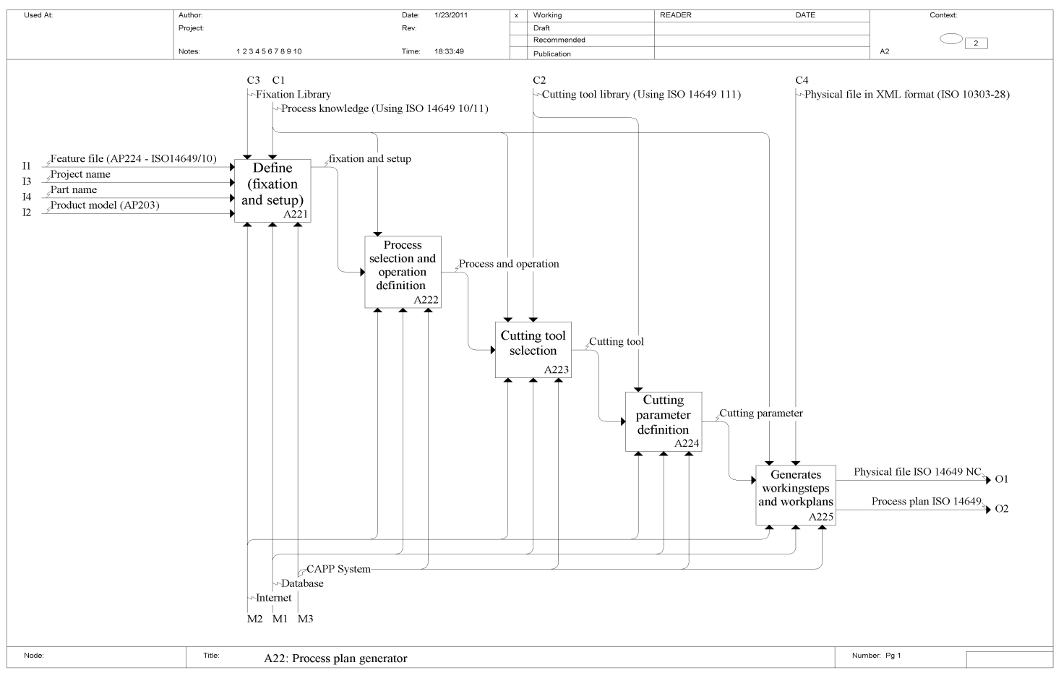
Figure 7. The corresponding modules to activity A22 (Process Plan Generator) of the CAPP module of the system.

3.3 CAM Module

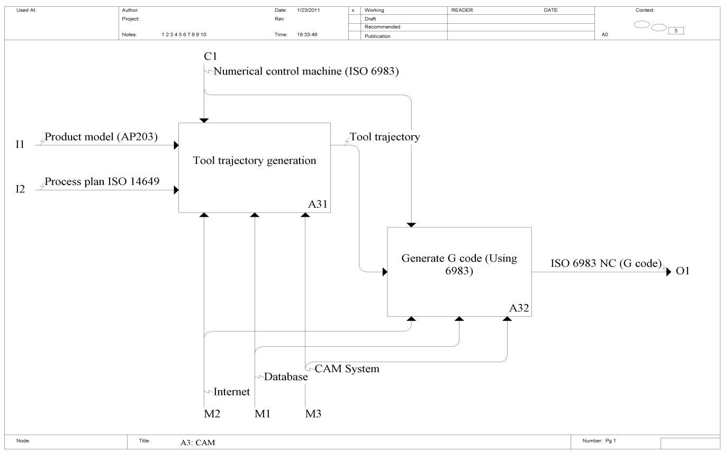
Figure 8. IDEF 0: Modules corresponding to the activities of the CAM module of the proposed system.

According to (Xun XU, 2009) Much like in the design and process planning domains, computers are also intimately involved in various manufacturing activities. In a general sense, computer-aided manufacturing refers to any computer applications to manufacturing problems, such as machine control, machine monitoring, simulation of manufacturing process, plant communication, mechanical testing.
The methodology activities for the CAM module can be viewed on the diagram IDEF0 of the figure 8, the proposed CAM module consists basically of two activities, the first is responsible for generating the tool path from the model piece in AP203 and also of the process planning in format ISO 14649 generated by the CAPP module. For the generation of this trajectory is used ISO 6983 standard (Numerical Control Machine), this information is used to generate the corresponding code G.

4. REFERENCES

Amaitik Saleh M., 2005. “Development of a step feature-based intelligent process Planning system for prismatic parts”, Middle East Technical University, april 2005.
JKemmerer, S, 1999. “STEP: The grand experience”, NIST special publication 939, Manufacturing Engineering
Laboratory, National Institute of Standards and Technology, july 1999.
International Organization for Standardization, ISO 10303-224, 2000. “Industrial Automation Systems and Integration-Product Data Representation and Exchange - Application Protocol: Mechanical product definition for process planning using machining features”.
International Organization for Standardization, ISO 10303- Part 11, 1997. “Descriptive methods: The EXPRESS language reference manual”.
International Organization for Standardization, ISO 10303-203,1994. “Application Protocol: Configuration controlled 3D designs of mechanical parts and assemblies”.
International Organization for Standardization, ISO 6983-1, 1982. “Industrial automation systems and integration – Numerical control of machines – Program format and definitions of address words – Part 1: Data format for positioning, line motion and contouring control systems”.
International Organization for Standardization, ISO 6983-2, 1982. “Industrial automation systems and integration – Numerical control of machines – Program format and definitions of address words – Part 2: Coding of miscellaneous functions M”.
International Organization for Standardization, ISO 14649 – 1, 2003. “Industrial automation system and integration – Physical device control – Data model for computerized numerical controllers – Part 1: Overview and fundamental principles”.
International Organization for Standardization, ISO 10303-238, 2006. “Industrial automation system and integration – Product data representation and exchange – Part 238: Application protocol: Application interpreted model for computerized numerical controllers”.
Xun Xu, 2009. “Integrating Advanced Computer-Aided Design, Manufacturing, and Numerical Control: Principles and Implementations”
Xu, X., and Mao, J., 2004. “Development of the client tier for a STEP compliant CAPP system”, In proceedings of the 6th international conference on frontiers of Design and Manufacturing.
Xu, X. (2006). “STEP-NC to complete product development chain, In Database Modeling for Industrial Data Management: Emerging Technologies and Applications”, edited by Z. Ma, pp. 148-184.

5. RESPONSIBILITY NOTICE

The authors are the only responsible for the printed material included in this paper.

