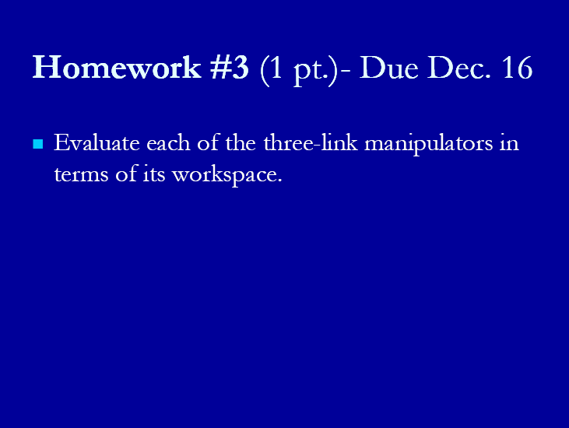

Evaluate five three-links manipulators in term of its workspace

1. Articulated manipulator (RRR)

In both of these arrangements joint axis z2 is parallel to z1 and both z1 and z2 are perpendicular to z0.

This manipulator provides for relatively large freedom of movement in a compact space.



Workspace of this manipulator is the biggest manipulator in five manipulators.

1. Spherical Manipulator (RRP)

By replacing the third or elbow joint in the revolute manipulator by a prismatic joint one obtains the spherical manipulator shown in below figure. The term spherical manipulator derives from the fact that the spherical coordinates defining the position of the end-effector with respect to a frame whose origin lies at the intersection of the three z axes are the same as the first three joint variables.

Workspace of this manipulator is the second biggest manipulator in five manipulators.



1. SCARA manipulator (RRP)

The SCARA has z0, z1, and z2 mutually parallel.

Workspace of this manipulator is the third biggest manipulator in five manipulators.



1. Cylindrical Manipulator (RPP)

Workspace of this manipulator is the fourth biggest manipulator in five manipulators.



1. Cartesian manipulator (PPP)



Workspace of this manipulator is the smallest manipulator in five manipulators.

References

[1] Karolis Sileika, Arunas Lipnickas, Design *of manipulator with two degree of freedom*, Kaunas University of Technology

[2]J.H.Shim, J.Y.Park, D.S.Kwon, H.S.Cho, and S.Kim,Kinematic Design of a six degree-of-freedom in parallel manipulator for probing task, International conference on robotics and automation, Albuquerque, New Mexico – April 1997

[3] M.W. Spong, S. Hutchinson, M. Vidyasagar,*Robot Modeling and Control*, John Wiley & Sons, Inc., 2005